|  |  |
| --- | --- |
| **AP Computer Science** | **TextLab03 Java Assignment** |
| **The Mortgage Payment Program** | **80, 90 & 100 Point Versions** |
| **Assignment Purpose:**  The purpose of this lab assignment is give students practice using **Math** class methods in a complicated formula for a practical program. A secondary purpose is to help students appreciate the effect of interest on a mortgage payment. | |

Write a program that will compute a monthly mortgage payment. A monthly mortgage payment is the same as a monthly loan payment. Normally, real estate loans are called mortgage loans. In this case you know the amount of the loan, called the **principal**, the annual **interest** paid, and the length of **time** to pay back the loan. The program needs to take that information and compute the monthly payment. Use the information and the provided formula below:

The letters in the formula below represent the following values:

**P** - - **Principal** amount borrowed, or loan amount

**R** - - **R**ate of interest computed for each month

**N** - - **N**umber of months to pay back the loan or mortgage

$$Monthly Payment=\left[\frac{R*{\left(1+R\right)}^{N}}{{\left(1+R\right)}^{N}-1 }\right] *P$$

|  |  |
| --- | --- |
| **TextLab03 Student Version** | **Do not copy this file, which is provided.** |
| // TextLab03st.java  // The Mortage Payment Program  // This the student, starting version of the TextLab03 assignment.  public class TextLab03st  {  public static void main(String args[])  {  System.out.println("TextLab03, Student Version\n");  double principal = 259000;  double annualRate = 5.75;  double numYears = 30;  System.out.println();  }  } | |

**Important Note**

Since you have not learned program input yet, the values of the principal, the annual rate of interest and the numbers of years to pay back the loan are hard coded in the provided program… however the formula requires the number of months to pay back the loan, not the number of years. There are also two issues with the interest. The number is written as 5.75, but 5.75% = 0.0575. On top of that you are provided with annual interest, but the formula requires monthly interest. In all of these cases, you need to make the program do the necessary conversions so the formula will work.

**Hard Coding Warning**

The only things hard coded in this program are the principal, the annual rate of interest and the numbers of years to pay back the loan. **Everything else must be computed by the program**. For example, a command like **numMonths = 360;** or worse **monthlyPayment = 1511.45** will cause you to earn a 0 on this lab. The program must do its own calculations.

**80 Point Version**

The 80 point version only computes the monthly mortgage payment.

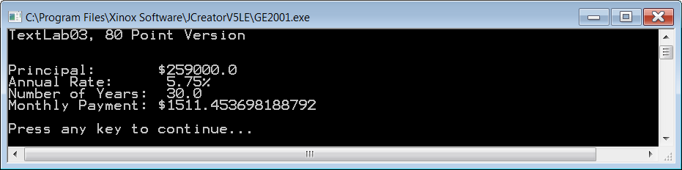

NOTE: For each version of the assignment, your output needs to be EXACTLY as shown here. If you are off by a few cents, or even a fraction of a cent, it does not mean the computer “just got a little off on its calculations”. It means your program was not written correctly.

**90 Point Version**

The 90 point version computes the monthly mortgage payment, and also computes the total payments and the total interest paid.

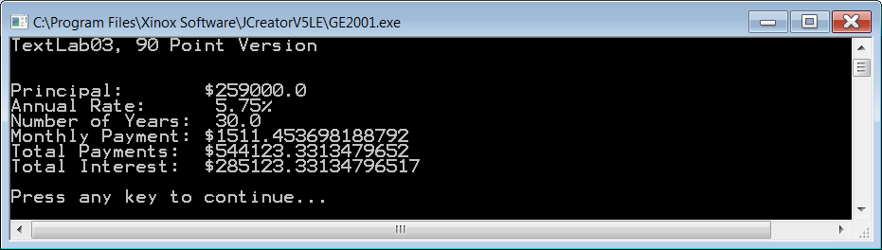

**100 Point Version**

In the 100 point version all calculations need to be rounded to the nearest penny.

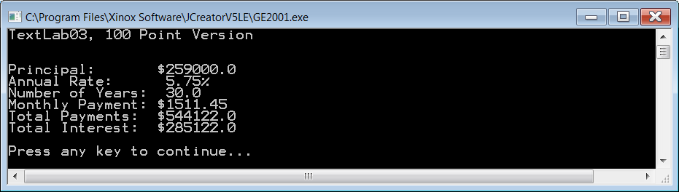

**Note for Students with Advanced Knowledge**

The 100 point version needs to be done using the Java commands learned in the first 4 chapters of Exposure Java. If you already know about the **DecimalFormat** class, you may be tempted to use it here. You need to refrain from this as it will actually cause you to get the wrong output.